SPONSORSHIP PACKAGES 2023

MINOR SPONSORSHIP PACKAGES
WHITE SPONSOR - $1,000 for 1 year – Currently Available
- Ground signage consisting of one 2.4 x 0.8 m banner on home match days
- Partnership with Taroona FC advertised at taroonafc.org
- Invitation to all Taroona FC events
- Exclusive member benefits
- Invitation to sponsors day events
BLACK SPONSOR - $2,000 for 1 year– Currently Available
- Ground signage consisting of one 2.4 x 0.8m banner on home match days
- One home match day dedicated to your business with promotional opportunities available
- Partnership with Taroona FC advertised at taroonafc.org
- Cross promotional opportunities via Taroona FC social media platforms
- Invitation to all Taroona FC events
- Taroona FC Supporters polo shirt, beanie and scarf
- Exclusive member benefits
Invitation to sponsors day events

MAJOR SPONSORSHIP PACKAGES
GROUND NAMING RIGHTS SPONSORSHIP – Currently Available
WHOLE OF CLUB PACKAGE – Currently Available
- Logo on sleeve of playing shirts for all Senior teams
- Logo on front of shirts for all Youth and Junior teams
- Ground signage consisting of two 2.4 x 0.8m banners on home match days
- Exposure through live streaming of WSL matches via NPL.tv
- Business logo on SKiLLS Training marquee used at tournaments and School Holiday clinics
- One home match day dedicated to your business with promotional opportunities available
- Partnership with Taroona FC advertised at taroonafc.org
- Cross promotional opportunities via Taroona FC social media platforms
- Brand promoted with weekly fixture and results listings on social media
- Invitation to all Taroona FC events
- Two tickets to our end of season Presentation Dinner
- Taroona FC Supporters polo shirt, beanie and scarf
- Exclusive member benefits
- Invitation to sponsors day events
WOMEN’S SUPER LEAGUE SENIOR MAJOR SPONSOR – TASSAL Sponsor & Hall Payne Lawyer Sponsor
- Logo on front or back of shirts for WSL Senior team
- Ground signage consisting of two 2.4 x 0.8m banners on home match days
- Exposure through live streaming of WSL matches via NPL.tv
- One WSL home match day dedicated to your business with promotional opportunities available
- Partnership with Taroona FC advertised at taroonafc.org
- Cross promotional opportunities via Taroona FC social media platforms
- Brand promoted with weekly fixture and results listings on social media
- Invitation to all Taroona FC events
- Two tickets to our end of season Presentation Dinner
- Taroona FC Supporters polo shirt, beanie and scarf
- Exclusive member benefits
- Invitation to sponsors day events
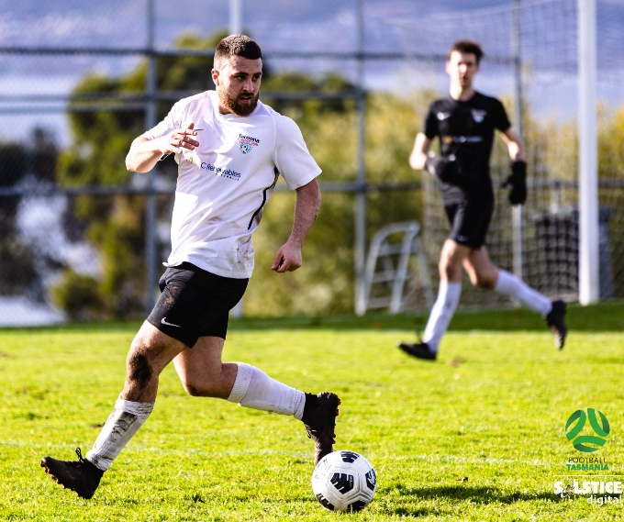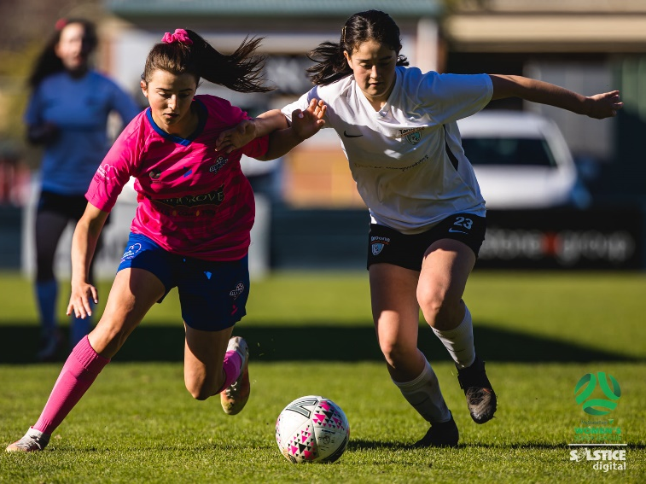

MEN’S CHAMPIONSHIP MAJOR SPONSOR – Front Shirt Sponsor is Currently Available. Back of shirt Sponsor is taken by ACEN Renewable.
- Logo on front of shirts for Senior men’s playing and training shirts
- Ground signage consisting of one 2.4 x 0.8m banner on home match days
- One Senior Men’s home match day dedicated to your business with promotional opportunities available
- Partnership with Taroona FC advertised at taroonafc.org
- Cross promotional opportunities via Taroona FC social media platforms
- Brand promoted with weekly fixture and results listings on social media
- Invitation to all Taroona FC events
- Two tickets to our end of season Presentation Dinner
- Taroona FC Supporters polo shirt, beanie and scarf
- Exclusive member benefits
- Invitation to sponsors day events
WOMEN’S CHAMPIONSHIP MAJOR SPONSOR – Currently Available
- Logo on front of shirts for Women’s playing shirt.
- Ground signage consisting of one 2.4 x 0.8m banner on home match days
- Partnership with Taroona FC advertised at taroonafc.org
- Cross promotional opportunities via Taroona FC social media platforms
- Brand promoted with weekly fixture and results listings on social media
- Invitation to all Taroona FC events
- Two tickets to our end of season Presentation Dinner
- Taroona FC Supporters polo shirt, beanie and scarf
- Exclusive member benefits
- Invitation to sponsors day events
WOMEN’S SUPER LEAGUE YOUTH DEVELOPMENT MAJOR SPONSOR – Hall Payne Lawyers Sponsor
- Logo on front of shirts for WSL Youth playing and training shirts
- Ground signage consisting of one 2.4 x 0.8m banner on home match days
- One WSL Youth home match day dedicated to your business with promotional opportunities available
- Partnership with Taroona FC advertised at taroonafc.org
- Cross promotional opportunities via Taroona FC social media platforms
- Brand promoted with weekly fixture and results listings on social media
- Invitation to all Taroona FC events
- Two tickets to our end of season Presentation Dinner
- Taroona FC Supporters polo shirt, beanie and scarf
- Exclusive member benefits
- Invitation to sponsors day events

ACADEMY AND JUNIOR MAJOR SPONSOR – Currently Available
- Logo on front of front of playing shirts for all Junior, SKiLLS Training and Academy teams.
- Ground signage consisting of two 2.4 x 0.8m banners on home match days
- Business logo on SKiLLS Training marquee used at tournaments and School Holiday clinics
- Partnership with Taroona FC advertised at taroonafc.org
- Cross promotional opportunities via Taroona FC social media platforms
- Invitation to all Taroona FC events
- Taroona FC Supporters polo shirt, beanie and scarf
- Exclusive member benefits
- Invitation to sponsors day events

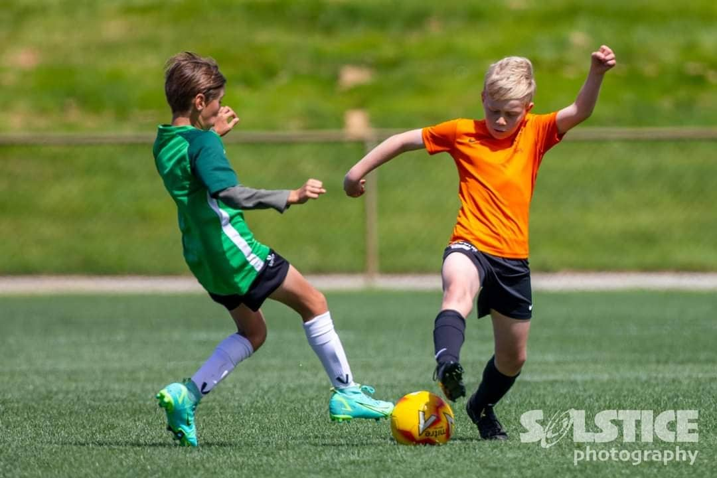
YOUTH SPONSOR – Currently Available
- Logo on front of front of Youth playing shirts
- Ground signage consisting of one 2.4 x 0.8m banners on match days
- Cross promotional opportunities via Taroona FC social media platforms
- Invitation to all Taroona FC events
- Partnership with Taroona FC advertised at taroonafc.org
- Taroona FC Supporters polo shirt, beanie and scarf
- Exclusive member benefits
- Invitation to sponsors day events
SOCIAL TEAM SPONSOR – Currently Available
- Logo on front of front of playing shirts for any Social team.
- Ground signage consisting of 2.4 x 0.8m banners on home match days
- Partnership with Taroona FC advertised at taroonafc.org
- Cross promotional opportunities via Taroona FC social media platforms
- Invitation to all Taroona FC events
- Invitation to sponsors day events

For further information:
President: Sam Johnson – president@taroonafc.org
Website: www.taroonafc.org
Facebook: https://www.facebook.com/TaroonaFootballClub
Instagram: https://www.instagram.com/taroonafc/

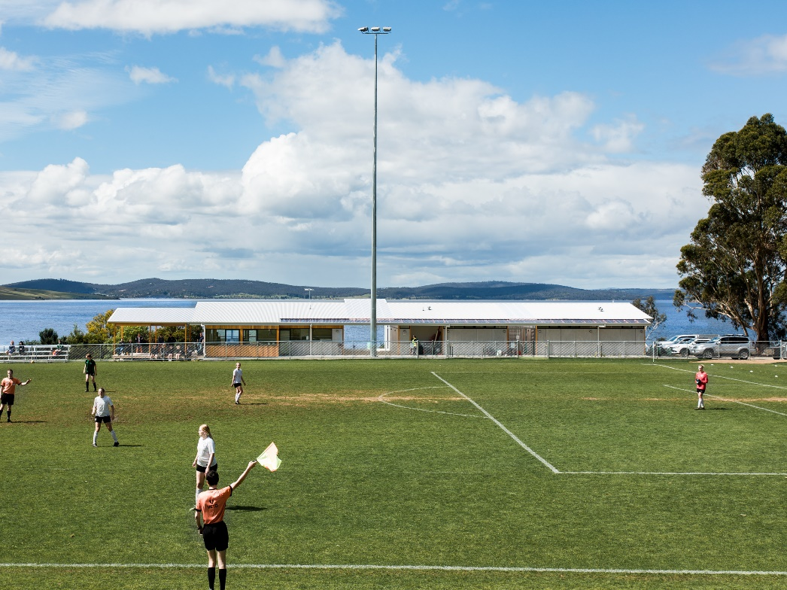
Natasha Mulhall Photography

